Lizzy Hutchens
ENGL 102
First Draft
March 18, 2022
Body Editor Applications and the Risks Posed by an Unrealistic Media-Ideal for Female Bodies in Western Culture
The media has long been disseminating societal messages to females concerning their physical appearance through beauty and body ideals and have done so by both hypersexualizing and objectifying the female body and by prioritizing certain features of the female body that most are pressured to attain. Historically and currently, Media messages compel women to fit the mold of Western beauty that idealizes thinness, and it is nearly impossible for women to resist or ignore the unrealistic body proportions that are valued in media and society. Constant exposure to media-ideal body standards has proven to lead many women to issues concerning body image, self-esteem, eating disorders, and other developmental or health-related issues, and while there are various unhealthy ways thinness manifests and is achieved for a female, the quickest way for a girl to “fix” her physical appearance for peers to see on social media is to edit herself through body editor applications. Body editor applications have become highly pervasive, are available to anyone with a smartphone, and are meant to help edit out any imperfections that one sees fit, but at a great cost. The cost comes to all who must share in the intake of a distorted reality caused by unrealistic self-images that many create for themselves and for others. Body modification photo-editing applications are perpetuating both a media-ideal body image for females and the objectification and sexualization of female bodies in media and society, in which there are various negative effects on aspects of a female’s mental, emotional, and physical health in the process that must be addressed in order to make social media a safer and more benevolent place for everyone.
The historical weight of structural sexism is ingrained in the media and has continued to amplify age-old pressures for young females to conform to idealized sexual narratives by idolizing toxic beauty and body standards. Media messages and society’s gendered expectations have long drilled in the idea that a girl’s most valuable asset was their beauty/body, and such messages are particularly problematic because once females internalize it, it prompts them to self-objectify because they see themselves more as an object for male gaze rather than a human-being. There are grave developmental effects of media-ideal internalization and self-objectification on females because not only does mass media portray primarily an “ultrathin physique for women,” which is a contributing factor of body discontent and eating pathology, but the women in Western cultures are highly sexually objectified in mass media, and their value and worth comes down to how attractive or thin they are, in which the two are often synonymous in this case (Dakanalis 998). The repetitive sexual objectification is a key issue in encouraging young women to endorse the unrealistic body shape ideals portrayed in the media, which ultimately causes them to view themselves as an object, and it can manifest as “habitual body surveillance, whereby individuals monitor their compliance with the gender-specific sociocultural body shape ideals to avoid negative judgments from others,” and self-objectification and sexualization are what fuels the usage of body modification photo-editing applications (Dakanalis 998).
Using body-editing apps to modify one’s body is the epitome of self-objectification and encourages many to over-sexualize their bodies to better fit the media-ideal, and there is correlational influence between overexposure to unrealistic representations of female bodies and resulting consequences such as body dissatisfaction, body dysmorphia, depression/anxiety, eating disorders, self-esteem, and body shame, to name a few (Benowitz-Fredericks 693). The usage of body editor apps to distort one’s own body image both instills and perpetuates self-objectification and the sexualized narrative of the female body, and exposure to post-edit pictures goes as far as to distort society’s reality of what a female body naturally looks like because mass media and social media convince viewers that such representations are the real deal without pre-edit pictures available to prove otherwise. For the sake of the health of women, it would be helpful if it were acknowledged when body modification filters are being used to stay realistic and authentic to viewers rather than enforcing an unrealistic media-ideal version that does more harm than good. There are already proven consequences of the damage that media-ideal physical standards can cause and yet there has been a surge in body editor applications and the amount of people that use it, in which a surge of health issues is sure to follow because usage of these apps only help to reinforce society’s media-ideal of female physical appearance standards.
Many health issues that follow stem from the effects of a theory that focuses on the impact of the sexual objectification of female bodies, in which the “objectification theory is the theory that most directly describes the process by which girls internalize the sexualizing messages of culture” (Zurbriggen 20). Self-objectification has girls adopting a third-person perspective on their physical bodies “in an effort to conform to the culture’s standards of attractiveness,” in which a woman is only a “good object” when she meets the prominent cultural standard of “sexy” and causes them to evaluate and regulate their bodies “in terms of their sexual desirability to others than in terms of their own desires, health, wellness, achievements, or competence” (Zurbriggen 20). Understanding how self-objectification and the thin media-ideal are interlocked is essential to understanding the negative consequences that arise from this, such as issues of body dissatisfaction and eating disorders. One study that aids in understanding this connection explores the integration of thin-ideal internalization and self-objectification in the prevention of eating disorders in an undergraduate sorority, in which the “cross-sectional path analysis indicated that thin-ideal internalization and self-objectification predict each other and both predict body dissatisfaction, which in turn, predicts eating disorders” (Kroon Van Diest 16). The results of the study suggest that targeting both thin-ideal internalization and self-objectification simultaneously within eating disorder prevention programs can aid in increasing the reduction of eating disorder symptoms. This information could help argue that using body editor applications for the purpose of modifying one’s body to fit the thin-ideal truly is perpetuating a media-ideal body image for females due to the toxic cycle of objectification and sexualization that eventually drives women to do it themselves.
Self-objectification goes beyond affecting one’s body image and eating pathology, it can go as far as to distort and even predict adolescent girls’ motor performance, in which self-objectification can account for the well-known phrase, “throwing like a girl,” as well as other “constrained and ineffective motor performances” that Western culture has socialized girls and women to adopt (Fredrickson 79). There is such great consequence for individuals who internalize media ideals or are invested in appearance for self-evaluation because they are “more vulnerable to experiencing body shame and then engaging in disorder behaviors” (Dakanalis 217). In a culture where the body is considered a symbol of personal success or failure, in which “beauty and slenderness are generally associated with happiness and social acceptability, [and] being overweight or out of shape are linked to laziness, lack of self-discipline and being out of control,” it is difficult for those who don’t fit the social norm to cope with oblivious standards (Dakanalis 217). Media pressure is central to the development of negative feelings about the body (i.e., body shame) and it is related to a great deal of psychopathological problems such as eating disturbances (Dakanalis 218). The emotional and behavioral responses to a woman’s desire to meet Western cultural ideals of physical appearance and attractiveness is the source of what makes body editor applications thrive, because these applications benefit in knowing how many women are desperate to look ideal to peers and society on social media.
Social media has created a toxic space and cycle where many women feel pressured to alter their appearance to feel accepted online, and body editor apps contribute to this pressure significantly by creating a simple ‘solution’ for people to alter their body and encourage others to conform to society’s pressures instead of accepting difference and supporting individuality. The pressure has led many to only share a sculpted ‘version’ of themselves on social media accounts, which often begins by comparing themselves to others on social media who are often using editing apps as well, also known as social comparison (Criddle). After internalizing media-ideal versions of others, more and more begin using body editor apps to find a level of comfort and confidence in the version of themselves that they have created. If those edited pictures receive any praise, it can fuel the belief that the sculpted version is better than the real version and perpetuates body image issues in the sense that it may become difficult to accept or even look at the real version of their body in the mirror, which leads to serious problems with body image and mental health such as the increase in body dysmorphia due to social media apps (O’Connor).
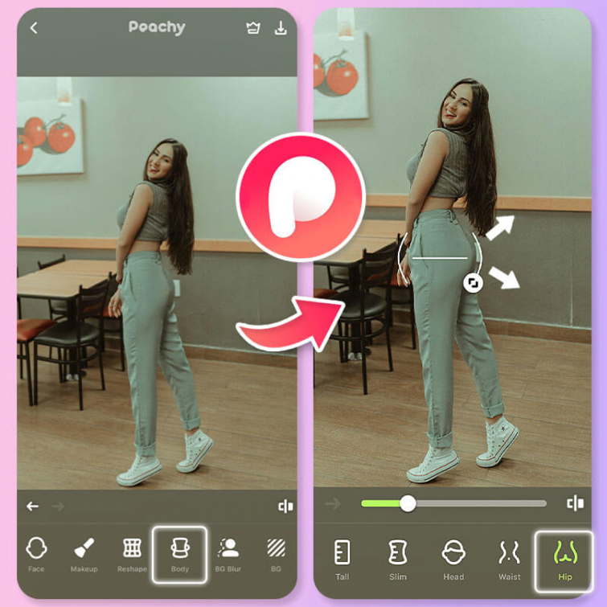
Body editor apps fuel weight stigma for women and promote the idealization of thinness, and this unfortunately contributes to an increase in body image issues and eating disorders in society (Criddle). In the words of body editor app creators, body editing features on apps include, “body reshape options to slim down your waist and give you a skinnier body,” “naturally reshape any body part you want,” “body editing tools such as muscle overlay, height adjustment, slimming option, and others,” in which it encourages females to slim down and accentuate certain sexual areas of our bodies (see fig. 1).

Fig. 1. Peachy Body Editor App, “7 Best Body Editor Apps for IPhone and Android 2022.” Perfect, YouCam Perfect, 28 Feb. 2022, https://www.perfectcorp.com/consumer/blog/photo-editing/best-body-editor-apps-iphone-android.
These applications do not help in the cultivation of social media to become a safe space for women because they do not encourage women and girls to embrace their true and authentic selves and rather puts importance in the acceptance from peers in society before self-acceptance. Social media cannot grow into a positive, empowering space for recovery from negative body image while it continues to encourage and perpetuate the objectification and sexualization of one’s own body. Instead of using apps to create bodies deemed desirable, it is important to begin healing from diet culture and unrealistic body ideals so that women and those around them can start to make peace with who they are and can feel free to be themselves without public ridicule and pressure to conform.

Works Cited
Aubrey, Jennifer Stevens. “Effects of Sexually Objectifying Media on Self-Objectification and Body Surveillance in Undergraduates: Results of a 2-Year Panel Study.” Journal of Communication, vol. 56, no. 2, 26 Apr. 2006, pp. 366–386., https://doi.org/https://doi.org/10.1111/j.1460-2466.2006.00024.x.
Benowitz-Fredericks, Carson, et al. “Body Image, Eating Disorders, and the Relationship to Adolescent Media Use.” Pediatric Clinics of North America, vol. 59, no. 3, June 2012, pp. 693–704., https://pubmed.ncbi.nlm.nih.gov/22643174/.
Campbell, Denis. “Depression in Girls Linked to Higher Use of Social Media.” The Guardian, 3 Jan. 2019, https://www.theguardian.com/society/2019/jan/04/depression-in-girls-linked-to-higher-use-of-social-media.
Criddle, Cristina. “Body-Editing Apps on TikTok 'Trigger Eating Disorders'.” BBC News, 27 Mar. 2021, https://www.bbc.com/news/technology-56503546.
Dakanalis, Antonios, et al. “The Developmental Effects of Media-Ideal Internalization and Self-Objectification Processes on Adolescents' Negative Body-Feelings, Dietary Restraint, and Binge Eating.” European Child & Adolescent Psychiatry, 22 Nov. 2014, pp. 997–1010., https://doi.org/10.1007/s00787-014-0649-1.
Dakanalis A, Riva G. “Mass media, body image and eating disturbances: The underlying mechanism through the lens of the objectification theory.” Handbook on Body Image: Gender Differences, Sociocultural Influences and Health Implications, Nova Science Publishers, Inc., 2013. p. 217-235.
“The Dove Self-Esteem Project: Our Research.” Dove, 20 May 2020, https://www.dove.com/us/en/stories/about-dove/our-research.html
Fredrickson, Barbara, and Kristen Harrison. “Throwing Like a Girl: Self-Objectification Predicts Adolescent Girls' Motor Performance.” Journal of Sports and Social Issues, Feb. 2005, https://www.researchgate.net/publication/249676123_Throwing_Like_a_Girl_Self-Objectification_Predicts_Adolescent_Girls%27_Motor_Performance.
Kroon Van Diest, Ashley, and Marisol Perez. “Exploring the Integration of Thin-Ideal Internalization and Self-Objectification in the Prevention of Eating Disorders.” Body Image, Jan. 2013, pp. 16–25., https://pubmed.ncbi.nlm.nih.gov/23182310/.
Miller, Monica, et al. “Gender Differences in Movies Superheroes' Roles, Appearances, and Violence.” Ada: A Journal of Gender, New Media, and Technology, no. 10, adanewmedia.org/2016/10/issue10-miller-rauch-kaplan/.
Sandoiu, Ana. “How Does Social Media Use Affect Our Body Image?” Medical News Today, 19 Nov. 2018, https://www.medicalnewstoday.com/articles/323725.
Santarossa, Sara, and Sarah Woodruff. “#SocialMedia: Exploring the Relationship of Social Networking Sites on Body Image, Self-Esteem, and Eating Disorders.” Social Media and Society, 17 May 2017, https://journals.sagepub.com/doi/10.1177/2056305117704407.
Sen, Swagata. “Objectification and Exploitation of Girls and Women by the Mass Media and Social Media.” Rights of Equality: Promoting Gender Equality and Women Empowerment, 30 June 2019, https://www.rightsofequality.com/objectification-and-exploitation-of-girls-and-women-by-the-mass-media-and-the-social-media/.
“Social Media Apps Increase Body Dysmorphia.” Edited by Clare O'Connor, U-High Midway, 10 Nov. 2021, https://uhighmidway.com/13536/health-and-wellness/social-media-apps-increase-body-dysmorphia/.
Tiplady-Bishop, Lottie, and Amy Sharpe. “Apps Altering Body Shapes in Videos Are 'Crushing Young People's Self-Esteem'.” Mirror, 5 June 2021, https://www.mirror.co.uk/news/uk-news/apps-altering-body-shapes-videos-24256873.
YouCam, Team. “7 Best Body Editor Apps for IPhone and Android 2022.” Perfect, YouCam Perfect, 28 Feb. 2022, https://www.perfectcorp.com/consumer/blog/photo-editing/best-body-editor-apps-iphone-android.
Zurbriggen, Eileen, et al. American Psychological Association, Report of the APA Task Force on the Sexualization of Girls: Executive Summary, 2007, pp. 1–9. https://www.apa.org/pi/women/programs/girls/report-full.pdf

